

SUDOKU SOLVER VISUALIZER

An app to visualize steps of sudoku solving

Submitted by : submitted to:

Naman Singh Rahul Rajput Sir

CSES003|12218144

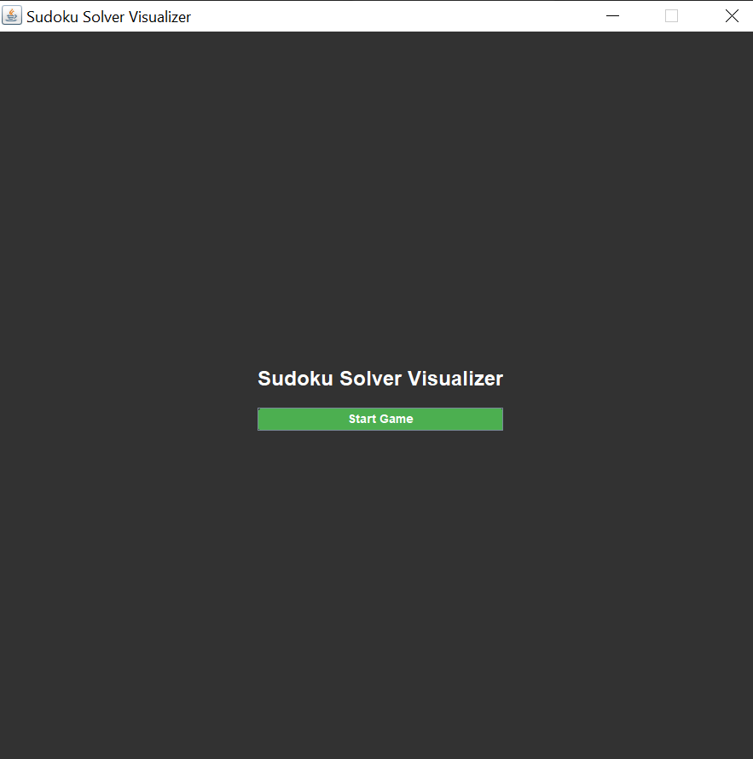

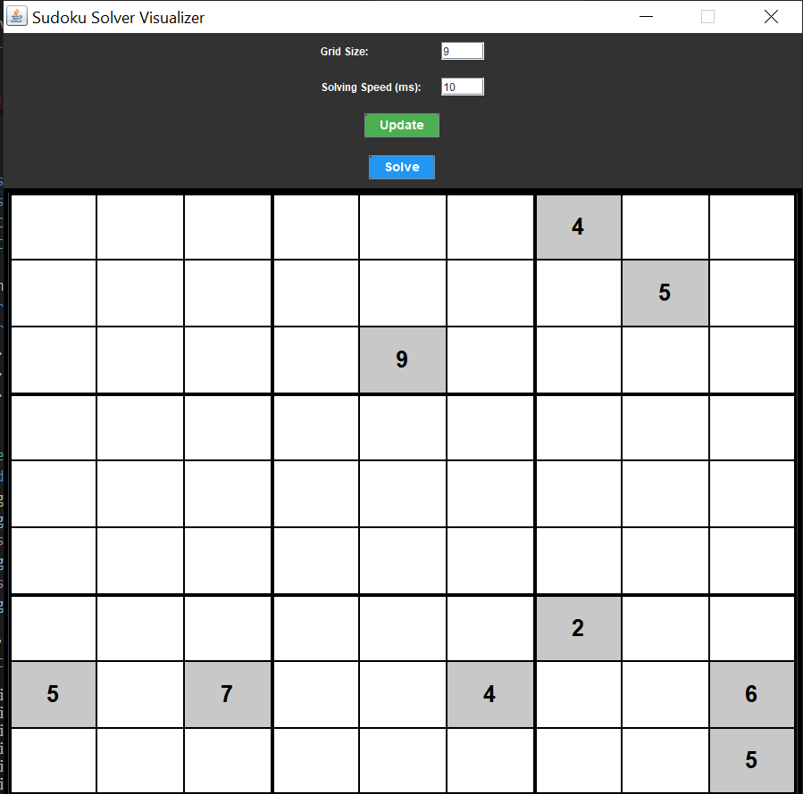

# Screenshot (140).png



# INTRODUCTION:

## </> Project Overview</>

Sudoku, a popular logic-based number-placement puzzle, challenges players to fill a 9x9 grid with digits from 1 to 9, ensuring that each column, each row, and each of the nine 3x3 subgrids contains all the digits without repetition. The puzzle, known for its engaging nature and ability to sharpen logical thinking, has inspired various computational approaches to solve it efficiently.

The "Sudoku Solver Visualization" project aims to provide a dynamic and interactive solution to this classic puzzle. Implemented in Java with the Swing framework, the project features a graphical user interface where users can input Sudoku puzzles, visualize the solving process, and receive real-time feedback on their entries. The solver employs a backtracking algorithm to systematically fill the grid, ensuring each placement meets Sudoku rules. Visual cues, such as color-coded feedback for correct and incorrect entries and dynamic updates upon solving, enhance user engagement and understanding of the solving process.

This project not only demonstrates practical application of algorithmic principles but also enhances user experience through intuitive visualization, making Sudoku solving both educational and enjoyable.

## </> Motivation</>

•**Educational Value**: Sudoku puzzles are renowned for enhancing logical reasoning and problem-solving skills. By visualizing the solving process step-by-step, this project aims to provide a learning tool that aids users in understanding complex algorithms and strategies used to solve Sudoku puzzles.

•**Interactive Learning**: Traditional Sudoku solvers often lack visual feedback, which can hinder user learning and engagement. This project fills that gap by offering a visually appealing interface that highlights correct and incorrect moves, thus facilitating a deeper understanding of Sudoku-solving techniques.

•**Practical Application**: The project bridges theoretical algorithmic concepts with practical application. By implementing a backtracking algorithm for Sudoku solving, users can witness computational problem-solving techniques in action, reinforcing concepts learned in academic settings.

•**User Experience Enhancement**: Existing Sudoku solver applications may lack user-friendly interfaces. This project addresses this by providing a streamlined, intuitive user interface where users can interact with the puzzle grid, input their own puzzles, and observe the solving process with clear visual cues.

•**Community Engagement**: Sudoku enjoys a broad following worldwide. By creating a visually appealing and functionally robust Sudoku solver, this project aims to engage and benefit Sudoku enthusiasts, educators, and developers interested in algorithmic problem-solving and interactive user interfaces.

# Features:

### </>Graphical User Interface (GUI)</>

1. **Interactive Grid Layout**: The GUI features a 9x9 grid layout where users can input Sudoku puzzles and observe real-time updates as the solver progresses through the solution.
2. **Color-Coded Cells**: Each cell in the grid is visually distinct, with black backgrounds for regular cells and light grey backgrounds for middle rows and columns, enhancing readability and structure within the puzzle.
3. **User-Friendly Controls**: Clear and intuitive buttons for actions such as solving the puzzle, generating a random board, and clearing the grid ensure ease of use and seamless interaction with the solver.
4. **Dynamic Feedback**: Text fields for each cell allow users to enter numbers directly, while color changes provide immediate feedback on the correctness of entries, helping users identify errors and correct them efficiently.

### </>Visual Feedback</>

1. **Color-Coded Validation**: Upon entering a number, cells dynamically change color—green for correct entries, red for incorrect entries—providing instant visual feedback on the validity of each move.
2. **Blinking Animation**: Incorrect entries trigger a blinking animation in red, alerting users to errors and guiding them to correct placements based on Sudoku rules.
3. **Completion Indicator**: When the Sudoku puzzle is successfully solved, the entire grid background transitions to green, signaling completion and providing a satisfying visual confirmation of the solution.

## Technology Stack:

### </>Programming Language: Java</>

Java was chosen as the primary programming language for its robustness, platform independence, and strong support for object-oriented programming. It provides the foundation for implementing the Sudoku solving algorithms, managing user interface components, and handling program logic efficiently.

### </>Framework: Swing</>

Swing, a part of the Java Foundation Classes (JFC), was utilized for developing the graphical user interface (GUI) of the Sudoku solver. It offers a comprehensive set of components (such as buttons, text fields, and panels) and layout managers to create interactive and visually appealing desktop applications. Swing's flexibility allowed for customizing the appearance and behavior of UI elements to suit the project's requirements.

### </>Integrated Development Environment (IDE): IntelliJ IDEA</>

IntelliJ IDEA was selected as the integrated development environment (IDE) for its advanced features, robust code editor, and seamless integration with Java development tools. It provided essential functionalities such as code completion, debugging support, version control integration, and graphical UI design tools through plugins and built-in features. IntelliJ IDEA's productivity enhancements facilitated efficient coding, testing, and debugging throughout the development lifecycle of the Sudoku solver visualization project.

## Implementation Details:

### </>Main Class</>

The Main class serves as the entry point for the Sudoku solver visualization application. It initializes an instance of SudokuVisualizer, which sets up the GUI components and handles user interactions. Here's an overview of its responsibilities:

* **Entry Point**: Contains the main method to start the application.
* **Initialization**: Instantiates a SudokuVisualizer object to initialize the GUI and set up event listeners for user interactions.
* **Integration**: Connects the user interface with the Sudoku solving logic implemented in the SudokuSolver class, facilitating seamless interaction between the user inputs and the solving process.

### </>SudokuSolver Class</>

The SudokuSolver class encapsulates the logic for solving Sudoku puzzles using a backtracking algorithm. It communicates with the SudokuVisualizer to update the UI during solving and provides validation methods to ensure puzzle rules are followed. Key details include:

* **Backtracking Algorithm**: Implements a recursive algorithm to systematically fill cells with numbers and backtrack when a solution is deemed invalid.
* **Validation Methods**: Checks the validity of number placements in rows, columns, and 3x3 subgrids to enforce Sudoku rules.
* **Integration**: Collaborates with SudokuVisualizer to update the GUI with solving progress, highlight correct and incorrect entries, and provide visual feedback to the user.

### </>SudokuVisualizer Class</>

The SudokuVisualizer class manages the graphical user interface (GUI) of the Sudoku solver application. It creates and manages UI components such as the puzzle grid, buttons for actions, and text fields for user input. Key responsibilities include:

* **GUI Setup**: Constructs the main frame with a grid layout to display Sudoku cells and control buttons.
* **User Interaction**: Handles user inputs through text fields for entering numbers and buttons for actions like solving, generating random boards, and clearing the grid.
* **Visual Feedback**: Updates cell colors dynamically based on user inputs and solving progress, using color-coded indicators to denote correct and incorrect entries.
* **Event Handling**: Implements action listeners to respond to user interactions, triggering appropriate actions in collaboration with the SudokuSolver class.

## Visual Enhancements:

### </>Visual Feedback and User Experience</>

* **Color Coding**: Implemented color-coded cells to indicate correct and incorrect entries, enhancing user interaction and understanding of puzzle solving.
* **Dynamic Updates**: Real-time updates to cell backgrounds and text colors provide immediate feedback on the validity of user inputs and solving progress.
* **Completion Indicator**: Upon solving, the entire grid background transitions to green, signaling completion and providing a satisfying visual confirmation.

## Challenges Faced:

### </>Implementation and User Interface Design</>

* **Algorithm Optimization**: Ensuring the backtracking algorithm efficiently solves Sudoku puzzles of varying complexities while maintaining responsiveness in the GUI.
* **User Interface Design**: Balancing aesthetics with functionality to create an intuitive and visually appealing interface that facilitates ease of use for users of all levels.

## Results and Observations:

### </>Functionality Testing and User Feedback</>

* **Accuracy and Efficiency**: Extensive testing confirmed the solver's accuracy in solving Sudoku puzzles within reasonable time frames, reflecting the effectiveness of the implemented algorithm.
* **User Engagement**: Positive user feedback highlighted the intuitive nature of the visual feedback system, which aided in learning Sudoku-solving strategies and techniques.

## Future Improvements:

### </>Enhancements and Future Development</>

* **Advanced Algorithms**: Implementing more advanced algorithms to tackle larger grids or more complex Sudoku variations.
* **Enhanced User Interactivity**: Adding features such as hints, difficulty levels, and statistics tracking to further engage users and enhance their Sudoku-solving experience.
* **Performance Optimization**: Continuously optimizing the solver and UI responsiveness to handle larger datasets and improve overall application performance.

## Conclusion:

### </>Achievements and Learnings</>

* **Educational Value**: The Sudoku solver visualization project successfully combines algorithmic principles with interactive user interface design to create an educational and engaging tool for Sudoku enthusiasts.
* **Practical Application**: By developing a robust solver and intuitive visual feedback system, the project demonstrates the practical application of Java programming, Swing framework, and algorithmic problem-solving in a real-world context.
* **Future Prospects**: The project lays a strong foundation for future enhancements and expansions, aiming to further enrich user experience and broaden the application's utility in both educational and recreational settings.

## *Acknowledgment*

I would like to express my sincere gratitude to Mr. Rahul Singh Rajput for his invaluable guidance, support, and mentorship throughout the development of this Sudoku solver visualization project. His expertise in Java programming and algorithmic problem-solving has been instrumental in shaping the project's direction and overcoming technical challenges. I am truly thankful for his encouragement, patience, and insightful feedback, which have significantly contributed to the success of this endeavor.

Thank You